**Deep Learning**

**Spring 2020**

**Lab #3**

**Date: 2020. 04. 30**

**ID/Name: 201533661 이승수**

**[HW#2]**

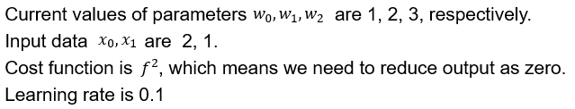



**What are parameters , after back-propagation once?**

**Answer)**

Firstly, I will change (w0*x0+w1*x1+w2) into character A. then I can get following results as below.

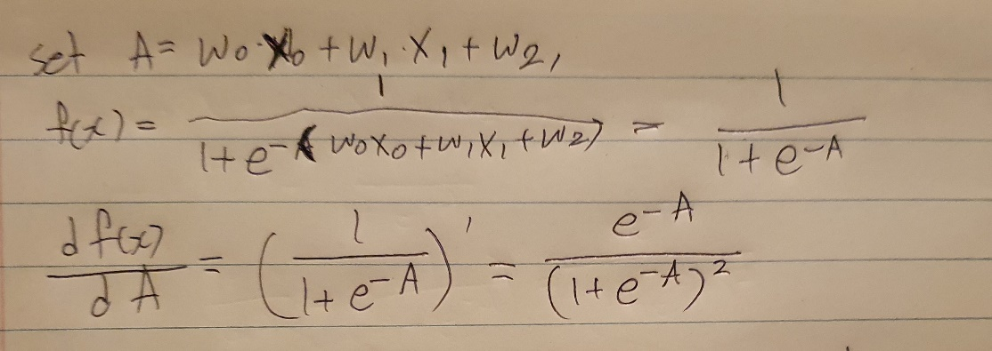

Then, we know w0=1,w1=2, w2=3, and x0=2, x1=1 as given, we can get following result as below.

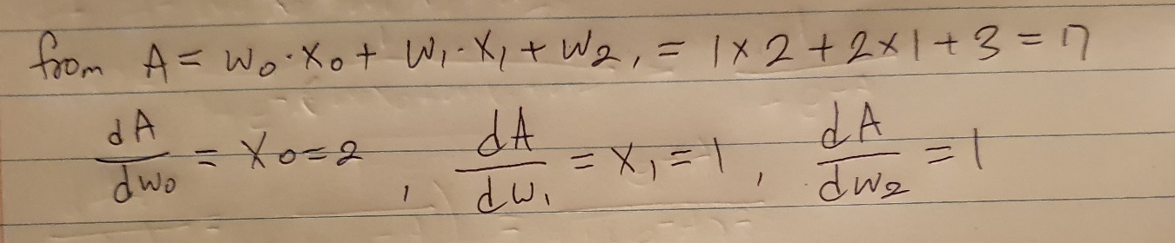

Cost Function(CF) is known as (f(x))^2, so we can get cost function as below.

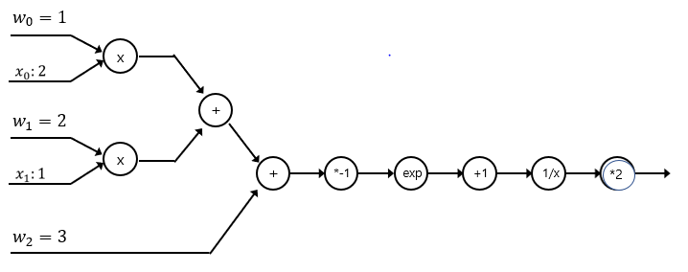

Then, we can calculate d(CF)/d(A) from Cost Function as below.

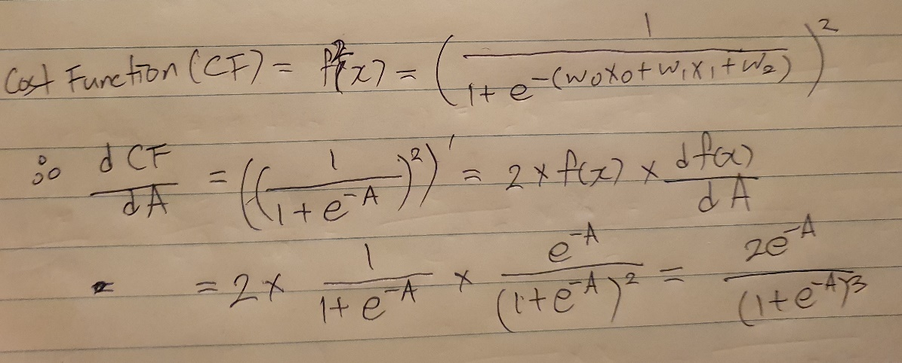

As result from above, we can get three results 1,2,3 as below. Remember the result for later.

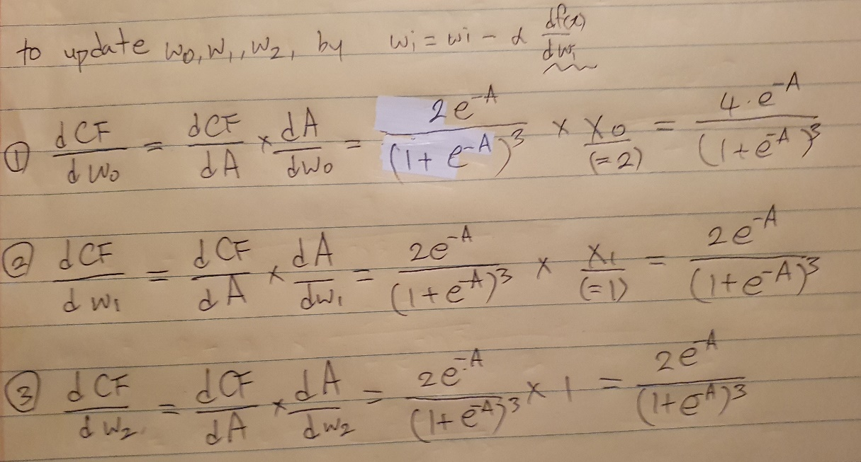

Using the result from above updating weight form is given as below, so we can get result from 1,2,3 results from above as below result.

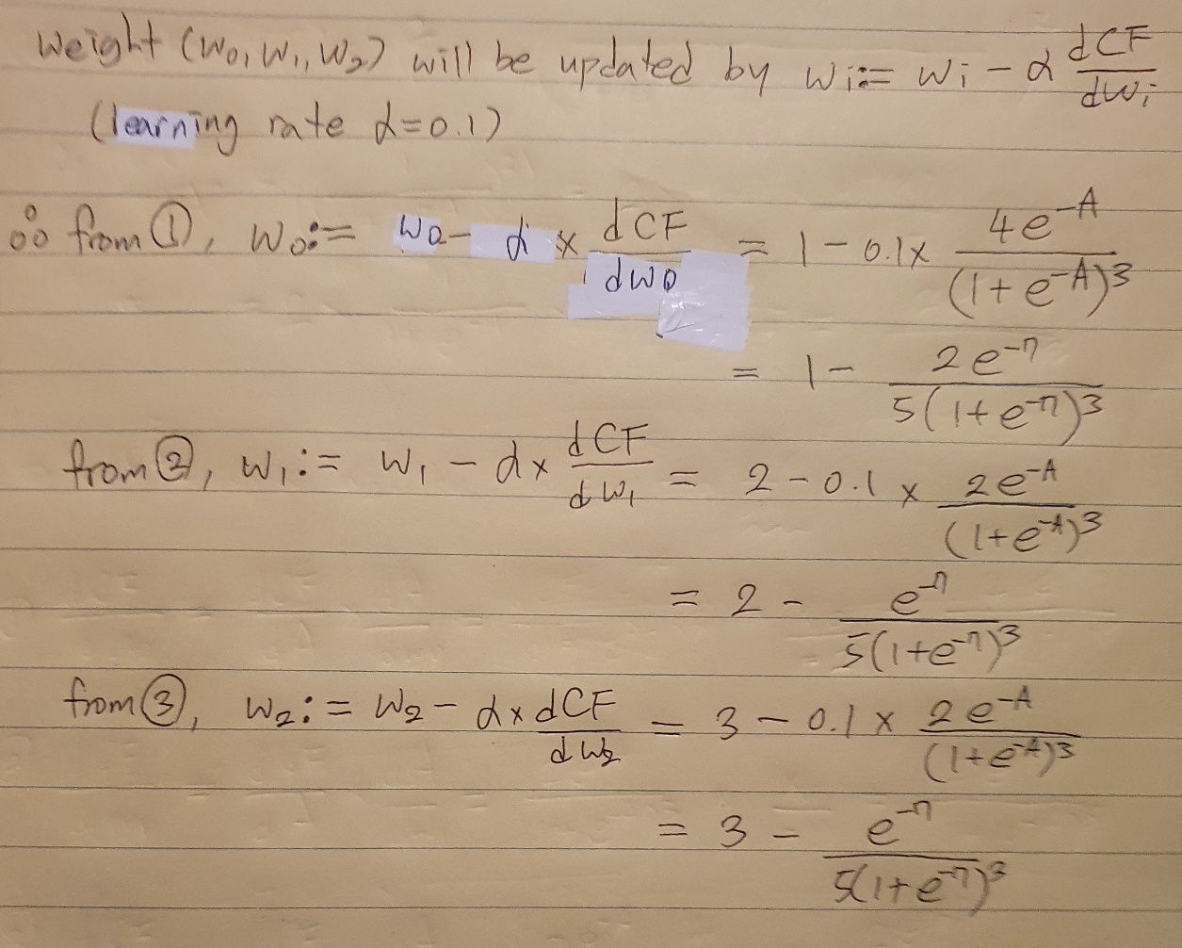

As a result, W0,W1,W2 weight values are updated as below, after one iteration.

